Ultrasound Experiments
Background: It is crucial to consider vascular pathologies while treating hypertension to tailor the prescriptions accordingly. Current anti-hypertensive therapies are purely based on the blood pressure cut-off values defined by the treatment guidelines. A vasodilator drug would be ideal for treating essential hypertension by relaxing the constricted smooth muscles lining the arteries. Similarly, a vasoconstrictor would be essential to treat hypotension whenever there is less tissue perfusion. Besides this, there is no treatment approach to address the vascular pathologies based on the understanding of arterial resistance and compliance. It is a known fact that arterial resistance and compliance determine the blood pressure and hence any pathology affecting the arterial resistance and compliance would in turn cause abnormalities in the blood pressures.

Objective 1 is aimed towards generating definitive evidence that resistance is at the level of small arteries alone while compliance is at the level of large arteries. Once proved, any change in BP due to a change in resistance can be attributed to small arteries and any change in BP due to a change in compliance can be attributed to large arteries. This way, it should be possible to address any vascular pathology that might be affecting large artery compliance or small artery resistance by administering a vasoactive drug that has differential effects on the component at fault. It is imperative to re-investigate every vasoactive agent that is currently used in anti-hypertensive therapy to redefine their action on the entire arterial tree. Resolving beat-to-beat resistance before and after administering a drug would be the way to achieve this goal. Post interventional changes in resistance would be indicative of the action of the drug on the small arteries whereas the compliance changes if any, would indicate that the drug is acting on large arteries.

Measurement of arterial vascular impedance is the first step towards beat-to-beat resolution of resistance and compliance which could be used for assessing the action of drugs on the arterial tree.

Measuring arterial vascular impedance:
Arterial vascular impedance can be calculated as the ratio of intra-arterial pressures to the blood flow in time domain or in frequency domain.
Arterial Vascular Impedance, $Z[k]$= $\frac{P[k]}{Q[k]}$, where P is intra-arterial pressure (in mmHg) and Q is blood volume-flow (in ml/s). Pressure and flow should be recorded simultaneously at the site of measurement (radial artery). Radial artery pressures are recorded using intra-arterial catheter and pressure transducer whereas volume flow is calculated as the product of blood flow velocity multiplied by the area of cross-section at the site of measurement.

Experiment set-up: Intra-arterial pressures is collected from the radial artery of the subject in the ICU (from patients who have intra-arterial line placed as part of their treatment) along with ultrasound imaging of the radial artery and doppler audio. The ultrasound images are captured using an externally mounted camera at 30fps. The pressures and the audio are sampled at a higher rate of 4KHz. All the three signals are collected using CMCdaq.

ALGORITHM:
STEP I: The following are the data collected simultaneously in CMCdaq (validated data acquisition system):
- Intra-arterial pressure (p[n]) at 4 KHz.

- Video recorded at 30fps.
- Audio recorded at 4KHz From Ultrasound Machine

STEP II: Conversion to frequency domain:
2.1. p[n] DFT P [$k]$ , Sampling rate= 4000 samples/s.
2.2. Calculation of volume-flow: q[n]
2.2.1. Frame-wise area calculation: a[n], n= frame no.
2.2.2. For one frame duration, no: of audio samples = 4000/30 = 133 samples/frame: x[n], N=133
2.2.3. x[n] DFT X [$k]$ Averaging = average doppler shifted freq (f_{D}) conversion to average velocity, v[n],
using, f_{D} $=\frac{2 .f.v\cos{}}{c}$ , f is the probe txn freq=11MHz, c is velocity of soud in blood=1580 m/s, θ = 45º -60º.
2.2.4. Hence, calculation of volume flow, q[n]= a[n]. v[n]
2.3. Conversion of q[n] to frequency domain:
q[n] DFT Q [k] Zero padding to 4000 samples IDFT q[n], N=4000

2.4. $Arterial Vascular Impedance, Z[k]$= $\frac{P[k]}{Q[k]}$; for non-zero values of P[k] and Q[k].
Background for analysis and interpretation: Consider the schematic of human cardiovascular system as shown in Figure 5. Heart is considered as an oscillating pump which is the source, and the sink is a chamber at the intra-thoracic pressure. The blood flow is analogous to fluid-flow in pipes and current-flow in electrical circuits. A simple linear systems model is the best way of simulating the circulatory system for understanding pathologies as it linearizes the complex fluid dynamics.
Figure 5. (Ref: 21): Devasahayam SR (2019). Signals and Systems in Biomedical Engineering: Physiological Systems Modeling and Signal Processing. Springer.

The following table (see Table 1.) shows the equivalence between fluid flow through pipes (or blood flow through vessels) and current flow in electrical circuits.

Table 1.
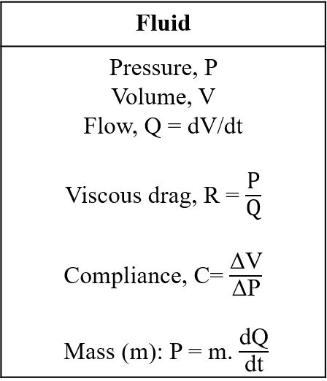
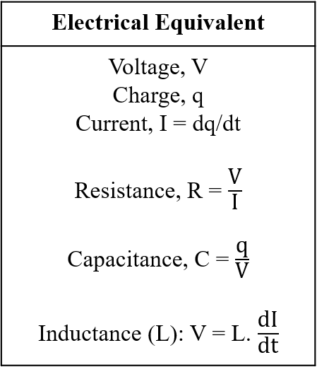

Compliance property of vessels help in accommodating more blood volume analogous to capacitive storage of charges. Resistance to blood flow in a vessel is analogous to the electrical resistance to current flow in an electrical circuit, while the inertance of the blood is analogous to electromagnetic inductance in an electrical circuit.
Now, consider the blood flow from heart, through aorta and larger arteries to the small arteries and arterioles (see Figure 6.a.) at the end organs. For the simplicity, a linearized lumped model representing this flow is shown in Figure 6.b. Mass is not considered in the model and source has an internal resistance as well which is not shown.
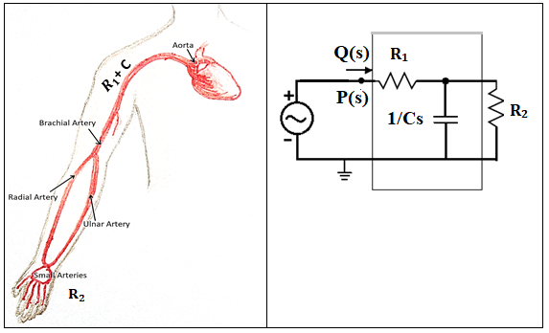
Figure 6.a. Figure 6.b.
We are interested in the vascular behavior of large and small arteries in terms of their resistance and compliance and hence the simplified lumped model above to differentially analyze large arteries (R1 and C) and small arteries (R2) in Figure 6.a. Figure 6.b. is in the Laplace domain for frequency domain analysis. P(s) is the ac-voltage source representing the pulsatile pump source (heart) and Q(s) is the current flow representing the blood flow in the circulatory system. R1 and C corresponds to resistance and compliance of large vessels (lumped) where as R2 is the small artery peripheral resistance.
Frequency domain analysis from the lumped model shown in Figure 6.b. yields net arterial vascular impedance.
In Frequency domain, net arterial impedance = Z(s) =
$$\frac{P(s)}{Q(s) }= \frac{(R1. R2. Cs + R2 + R1)}{(R2.Cs +1)}$$
$$\frac{P(j⍵)}{Q(j⍵)}= \frac{(\text{R}\text{1}. R2.j⍵C + R2 + R1)}{(R2.j⍵C +1)}= Z(j⍵)$$
$$\left| Z\left(⍵\right) \right|=\frac{\sqrt{\left({R1}^{2}+ {R2}^{2} +2 R1.R2 + {R1}^{2}.{R2}^{2}.⍵2.C2\right)}}{\sqrt{\left(1 + {R2}^{2}.⍵2.C2\right)}} →(1)$$
${∠ Z(⍵)= tan}^{-1}\left(\frac{⍵.C.R1.R2}{R2 + R1}\right)-\tan^{-1}{(⍵.C.R2)}$ $→(2)$
Arterial Vascular Impedance, |Z ($⍵$)| . ∠ Z ($⍵$)

Equations (1) and (2) both involve 3 unknowns - R1, R2 and C. The impedance values at 3 frequencies from Z versus frequency plot would yield 3 equations. Three unknowns can be estimated from 3 equations. This way, it would be possible to tease out any change in R1, R2 and C for any vasoactive drug that is administered (pre versus post). i.e., simply calculating beat to beat resistance and compliance changes for any vasoactive drug (since intra-arterial pressure and flow are continuously recorded over time), it would be possible to resolve its differential action on the entire arterial tree based on the evidence from the first objective and thereby tailor the anti-hypertensive treatments to correct that component at fault.

Results of the algorithm tested on normal volunteer:
- Data collected on CMCdaq:
  - Video at 30fps (externally mounted camera).
  - Doppler audio at 4KHz (external mic).
Sample Data from recording:
  - 1. The doppler sound was recorded at 4KHz and video was recorded at 10fps , using CMCdaq, simultaneously.
Extraction: The doppler signal was low pass filtered at 31 Hz cut off. Also, 50Hz noise was filtered; the negative time (in the extracted text file) was corrected so that the video and doppler signal starts at 0 time instant.

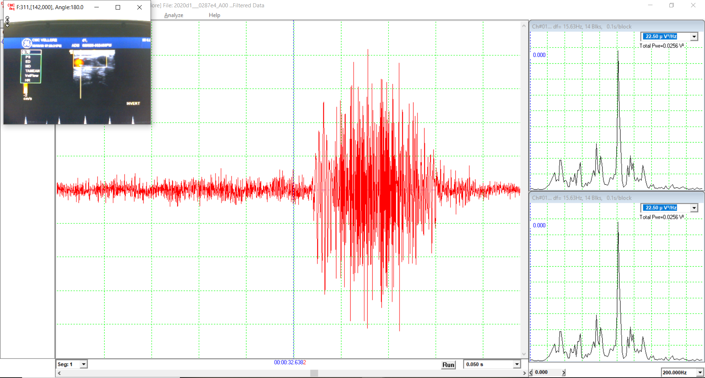one out one of the many bursts shown
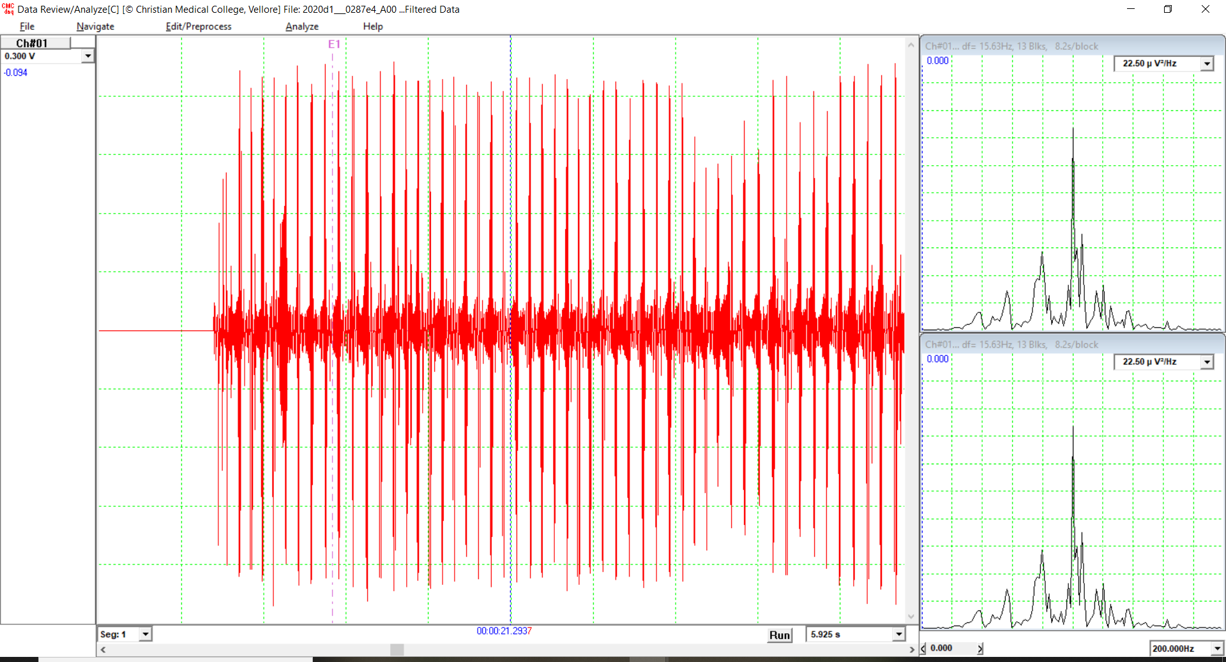

    - Intra-arterial pressure – can be collected simultaneously along with video and doppler on CMCdaq on another channel.

- Frame-by-frame calculation of flow-velocity in cm/s from recorded doppler audio signal:

- Frame-by-frame calculation of area of cross-section of radial artery from image frames from the video recorded using CMCdaq:

- Volume flow calculated in cm³/s (= area x flow velocity):

Algorithms used for area and flow calculations:
- Mean flow velocity frame-wise:

Extract frames from videos:
For each frame count + Area calculation Algorithm (‘$a$’ sq.cm) – see step2

Get the frame current time: t2

Get start time, t1, for this frame: t2-(1/frame rate)

Extract the doppler signal data between t1 and t2

Determine the L-point DFT spectral density of this L-point signal segment

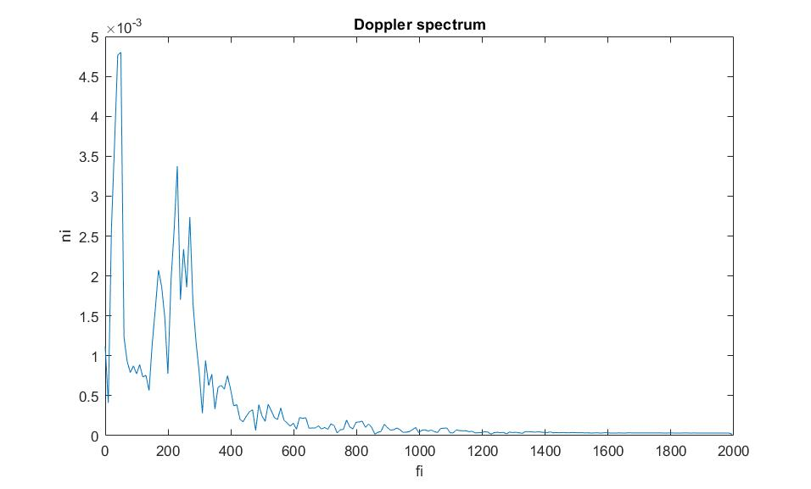

${Mean doppler frequency, f}_{D}=\frac{\sum_{i=0}^{\frac{L}{2}-1}{\left(f_{i} . n_{i} \right)}}{\sum_{i=0}^{\frac{L}{2}-1}{\left( n_{i} \right)}}$

$$f_{i }:i^{'}th discrete frequency component from the spectrum$$
$$n_{i} :the power spectral density of the i^{'}th frequency component$$

Mean doppler shifted frequency, f_{D} $=\frac{2 .f.v\cos{}}{c}$
Hence, Mean velocity, $v$ = $\frac{f_{D}. c}{2.f.\cos{}}$

Where, velocity of sound in blood, c = 1580m/s ; $=angle of insonation ;f=transmitted frequency=8MHz;$ (convert to cm/s)

For this frame, calculate volume flow, $q =a. v$ ; in cc/s
Repeat over all frames

- Frame-wise area (‘a’) calculation:

Extracting frames from the video (30fps)

CLAHE method of histogram equalization

Binarize the image frame

Split to R, G, B layers

Eliminate the background- doppler window +
patient details + any other legends
from Ultrasound screen: F = R-G

Iterate over (5x5) pixel neighborhood to detect the boundary for F
based on the white pixel count

Find row_max and row_min;
col_min and col_max of F. This would be
the region of interest for segmentation of the image frame.

POST SEGMENTING desired window:
Find all the connected components

Find the largest connected structure

Determine the calibrated area from pixel count

Calibrate area ‘$a$’ to standard units (sq.cm) based on positioning and ppi of cam used.

Iterate over each frame and save to csv
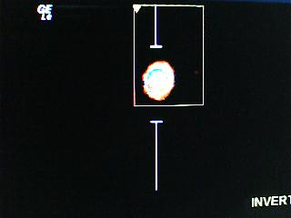 area calculation for the region of interest 

